Navigate to the directory where the docker-compose file is present and open in terminal

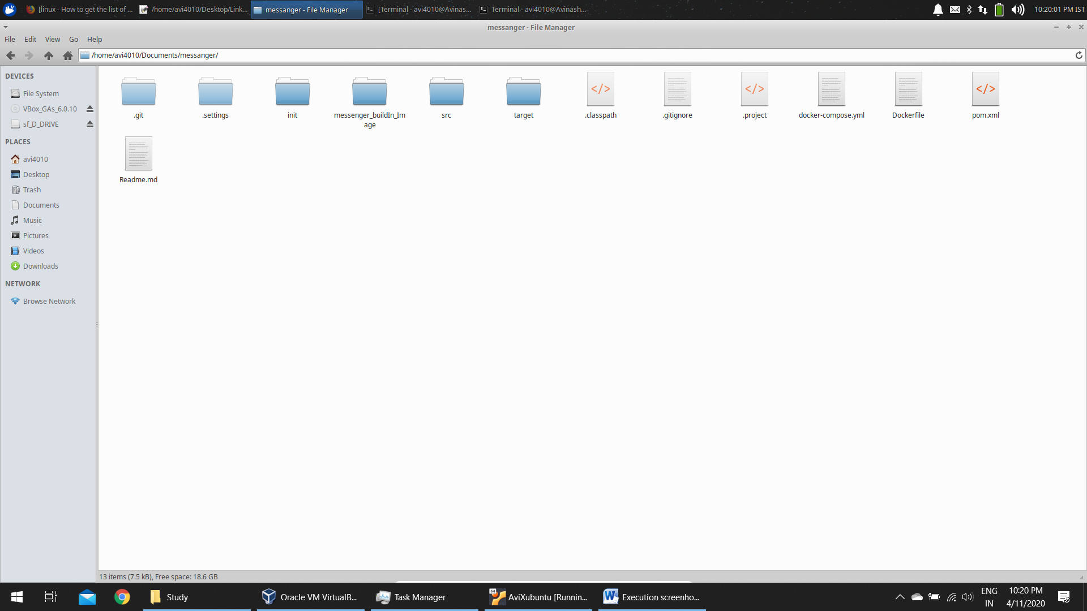

Check for the current images

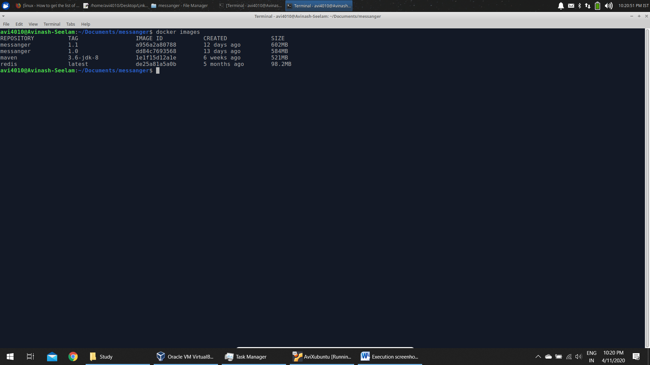

Now type ‘docker-compose up –d’

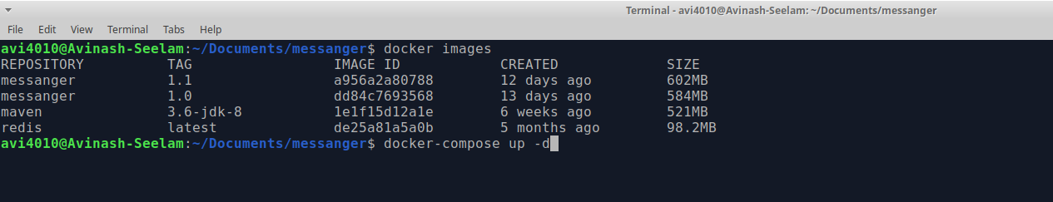

After the build is complete

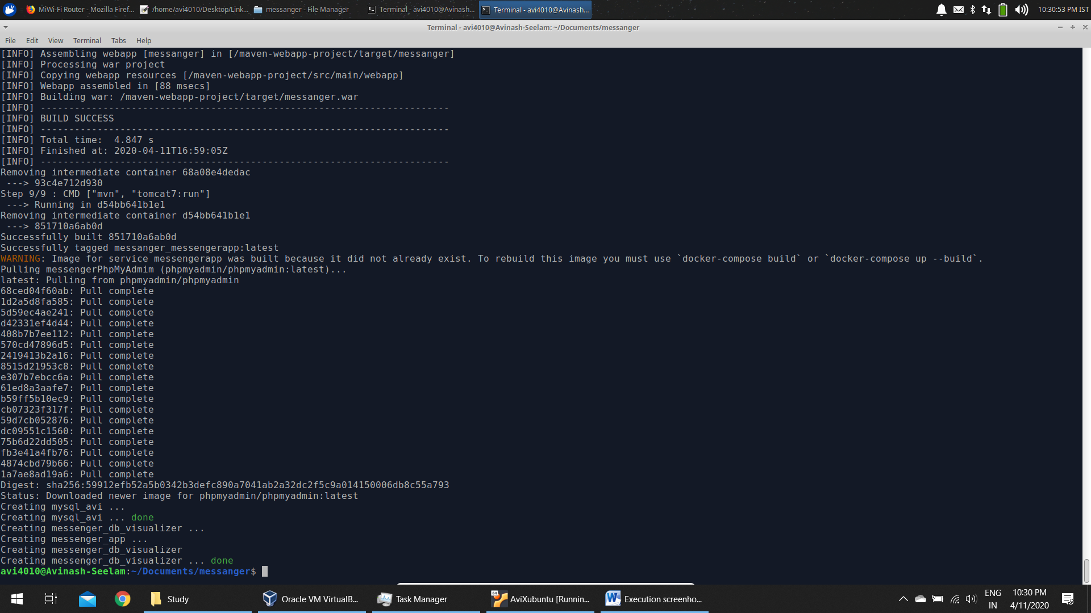

Check docker-compose ps

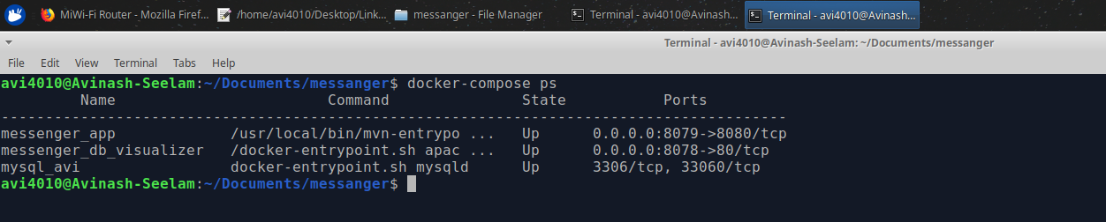

Access the application in <http://localhost:8079>

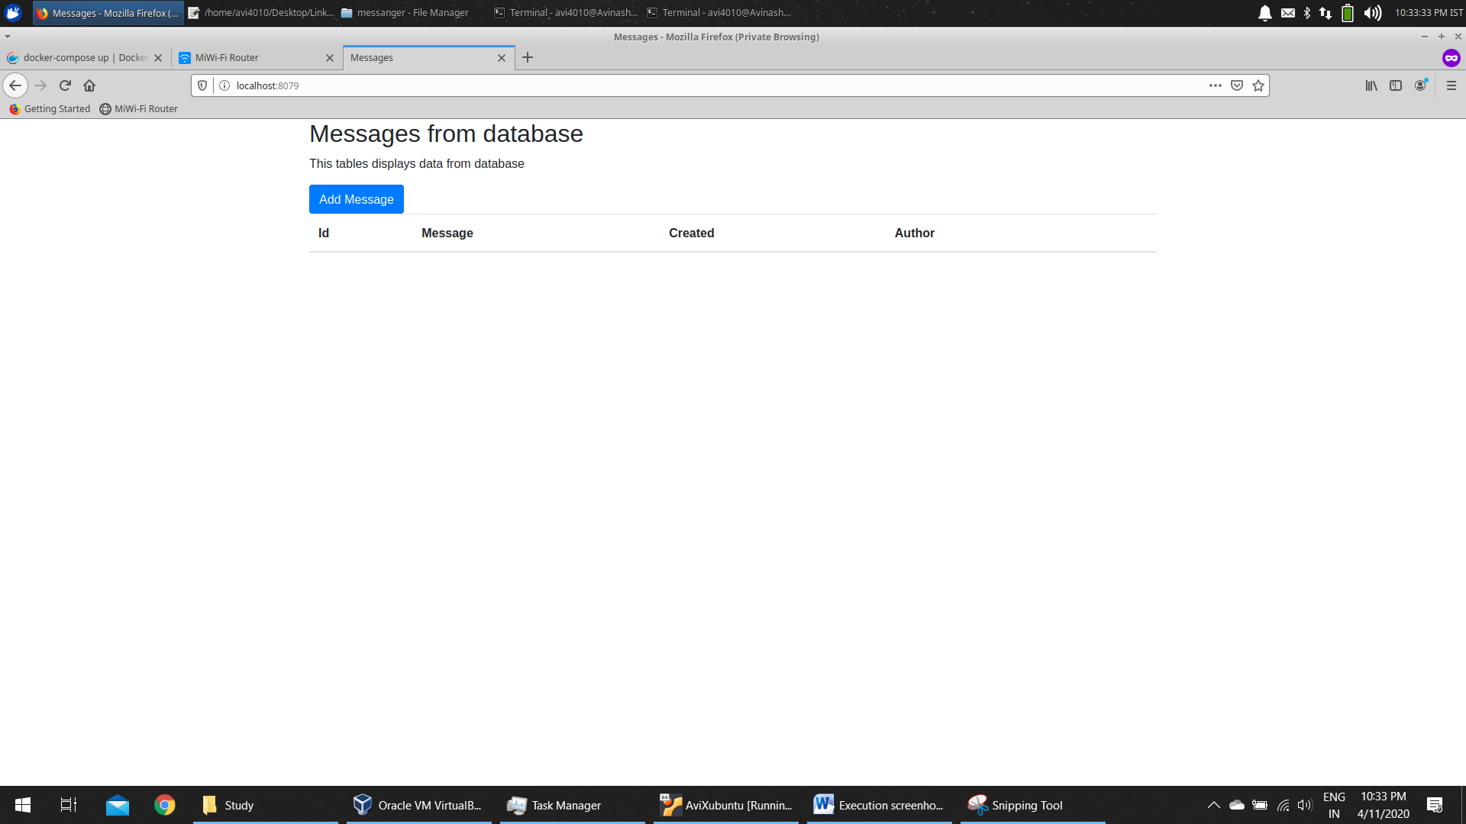

Currently No Data is displayed. So, add some data (Click on ‘Add Message’)

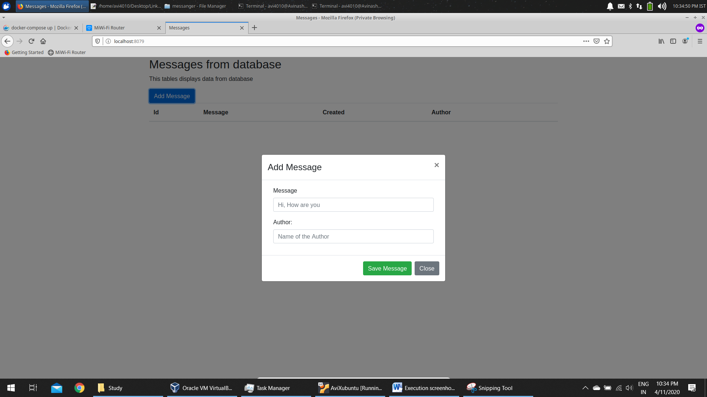

Enter the values

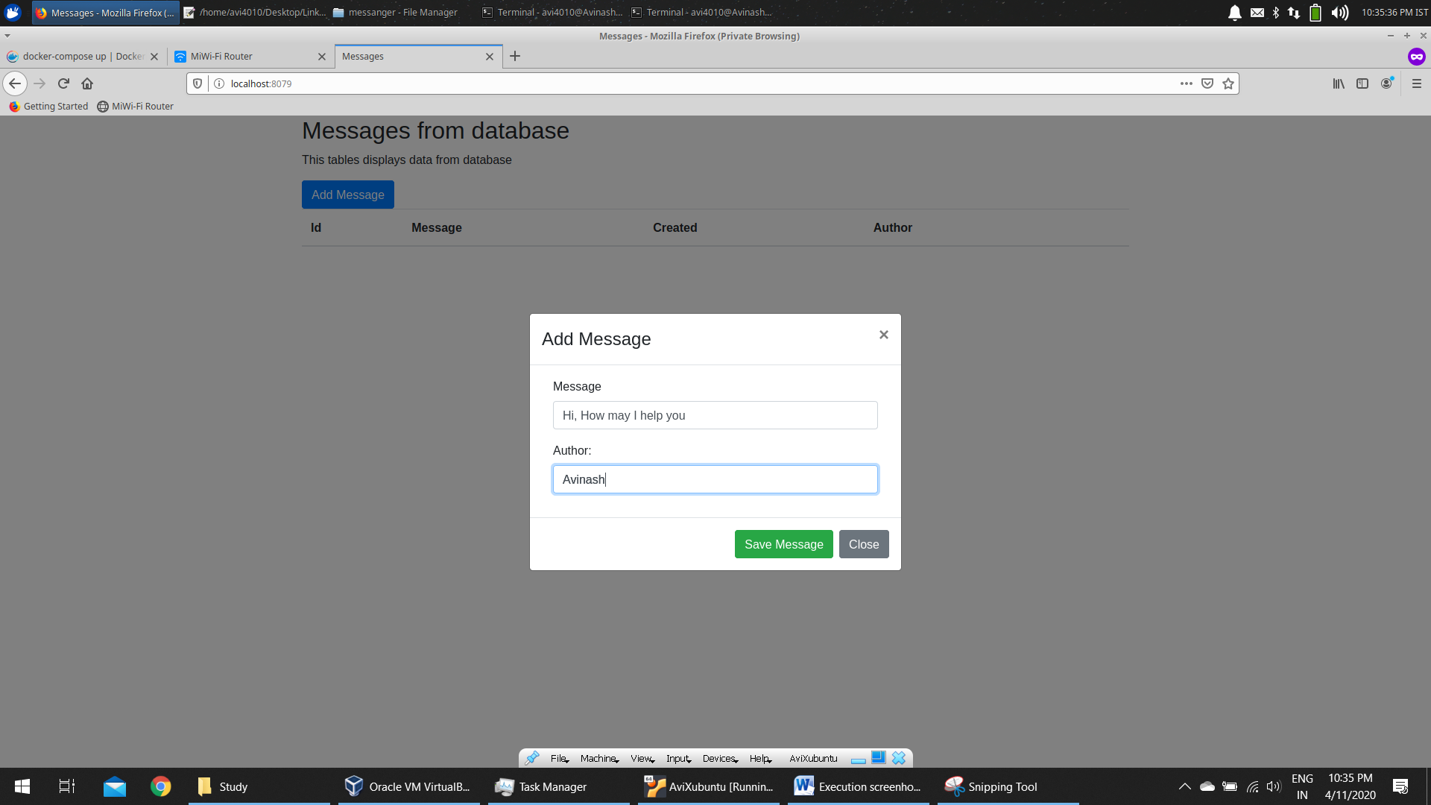

Click on Save Message

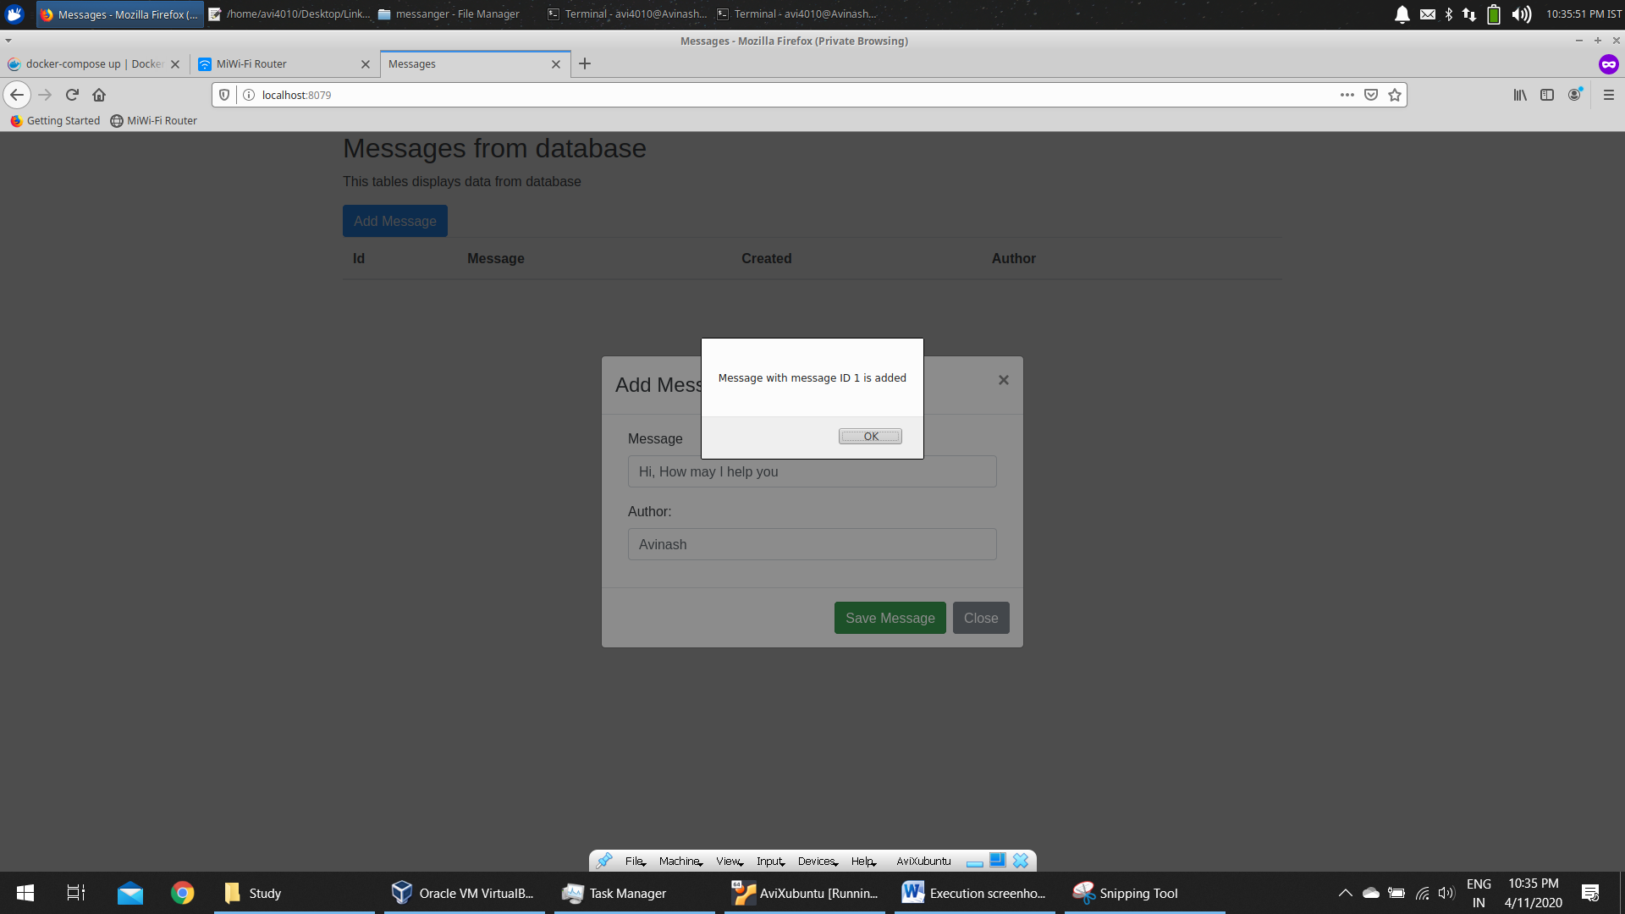

Value is inserted

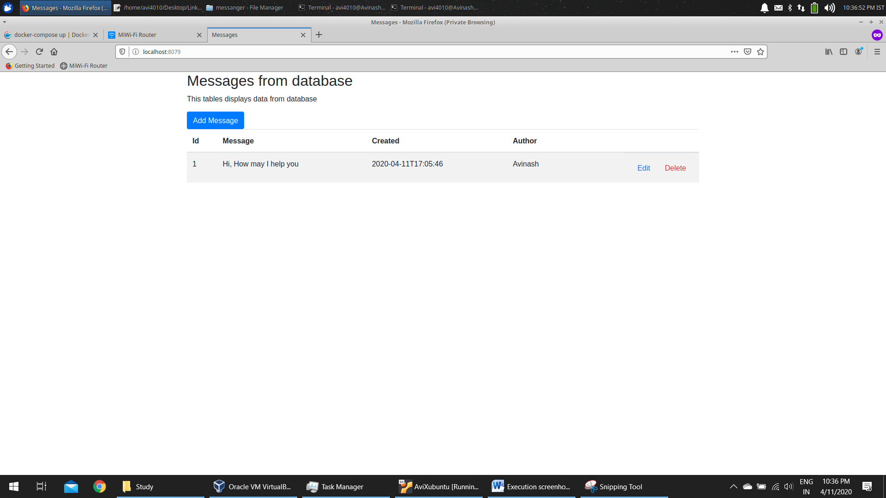

Add another message similarly

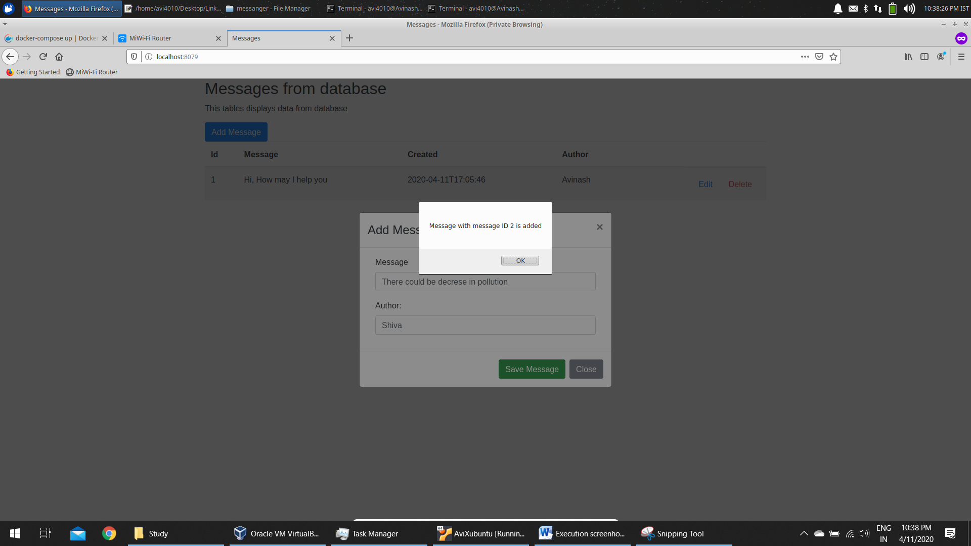

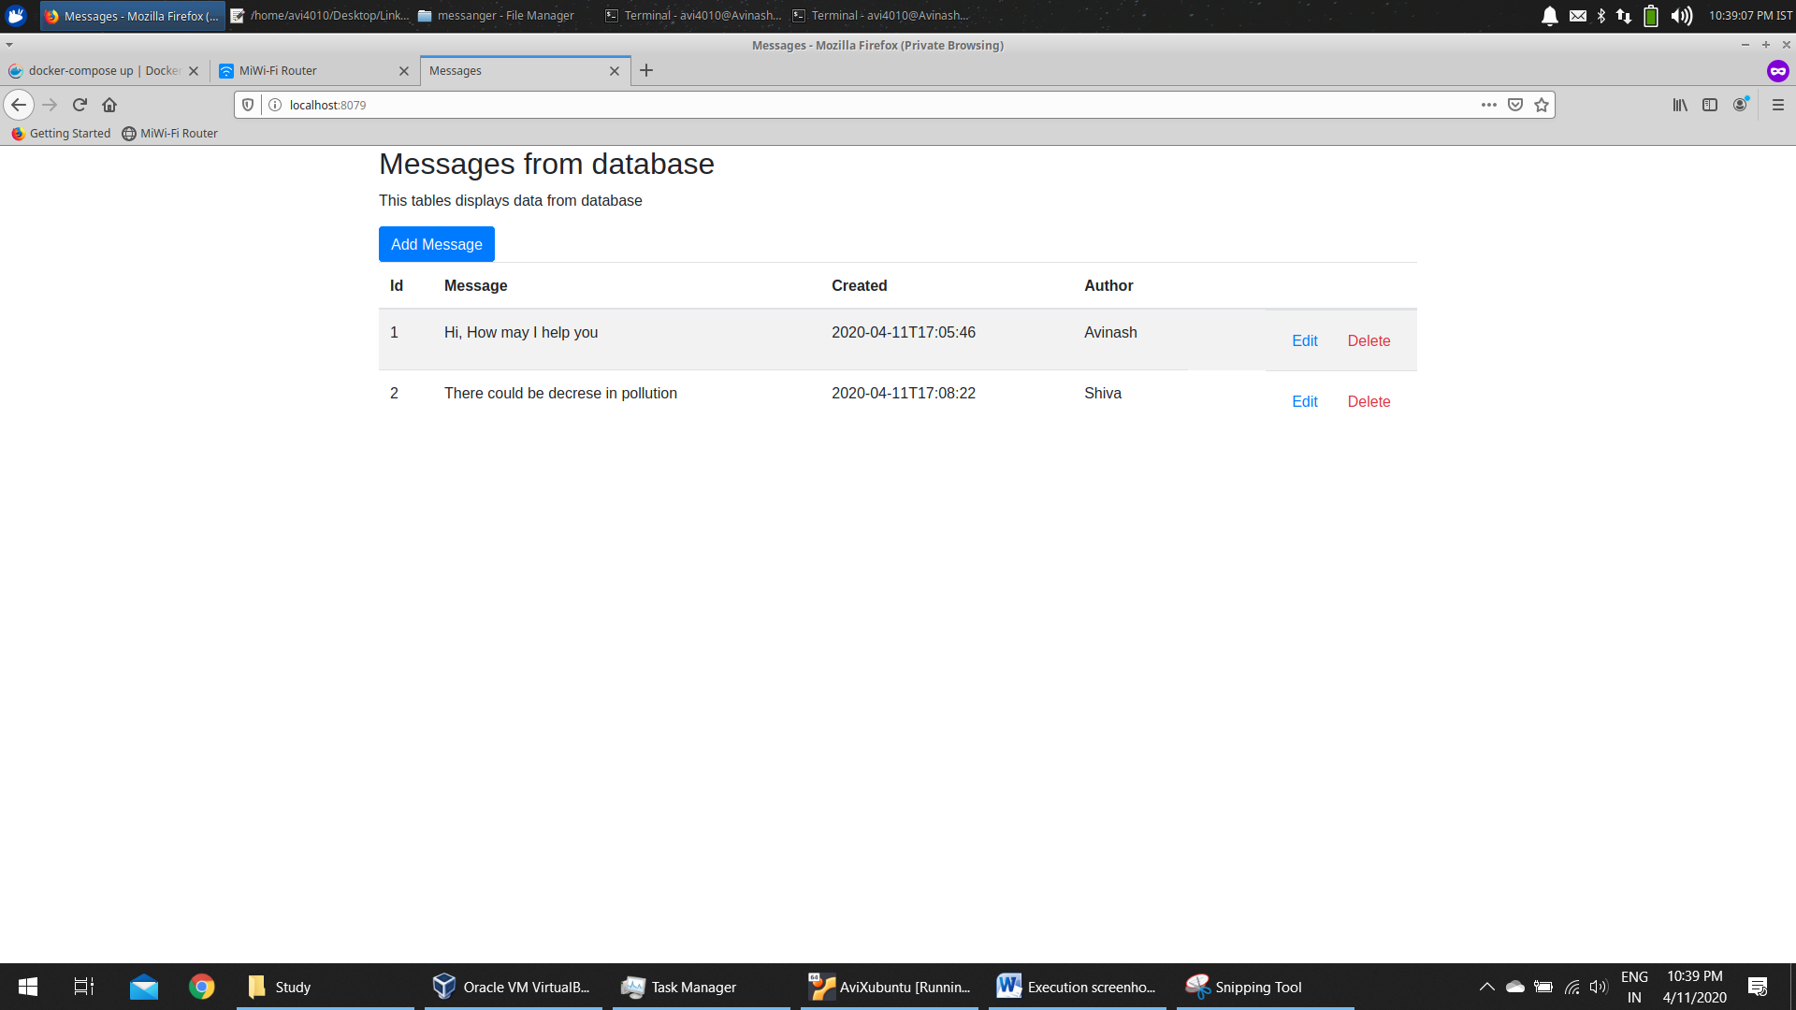

Add 2 more message like that

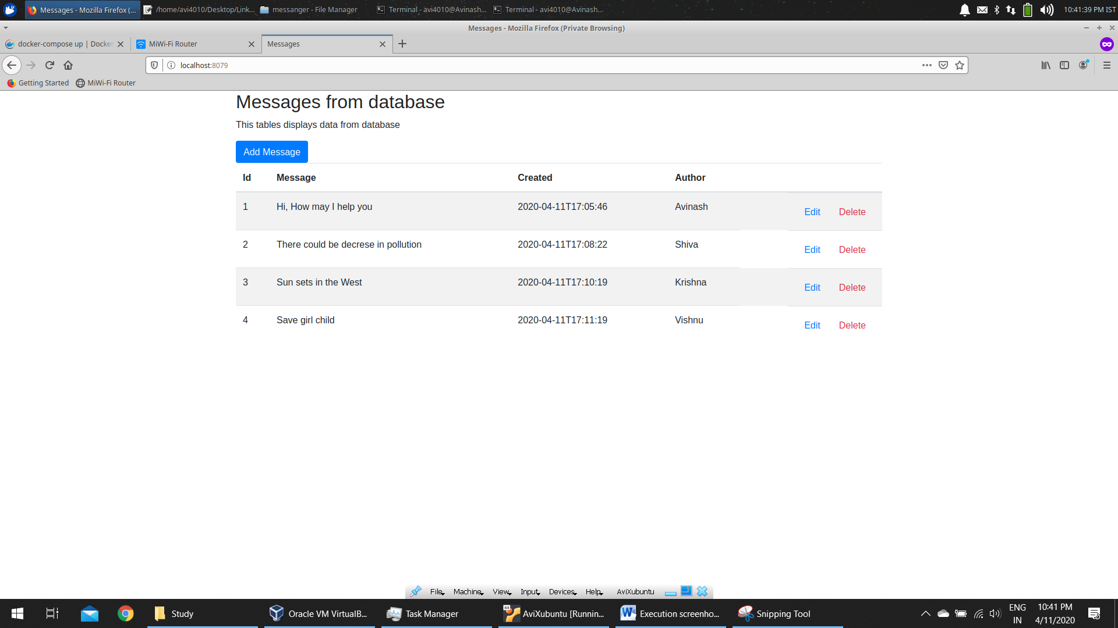

You can see the data in MSQL DB from phpMyAdmin container which is running in 8078 port of host

Now, access <http://localhost:8078>

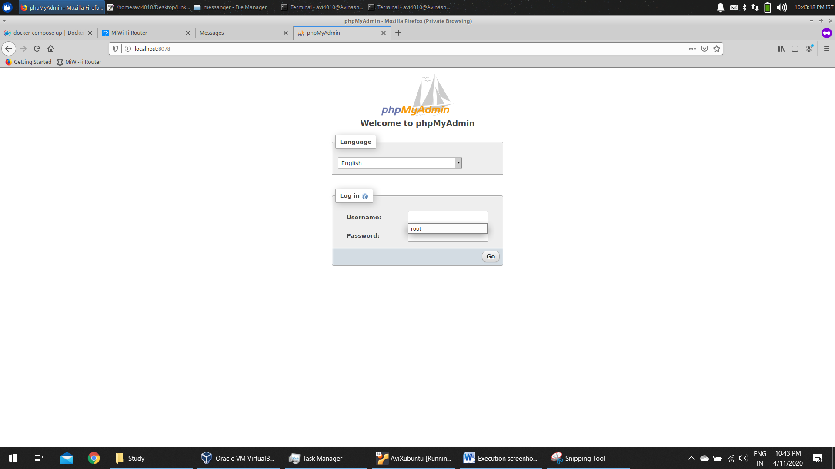

Enter username as ***root*** and password as ***root*** and click on go button

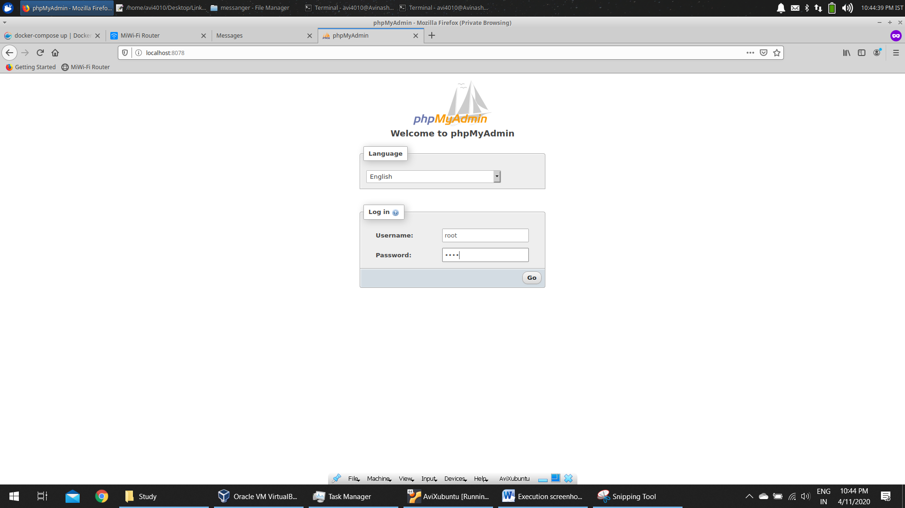

Click on the messengerdb table in the left side of the page

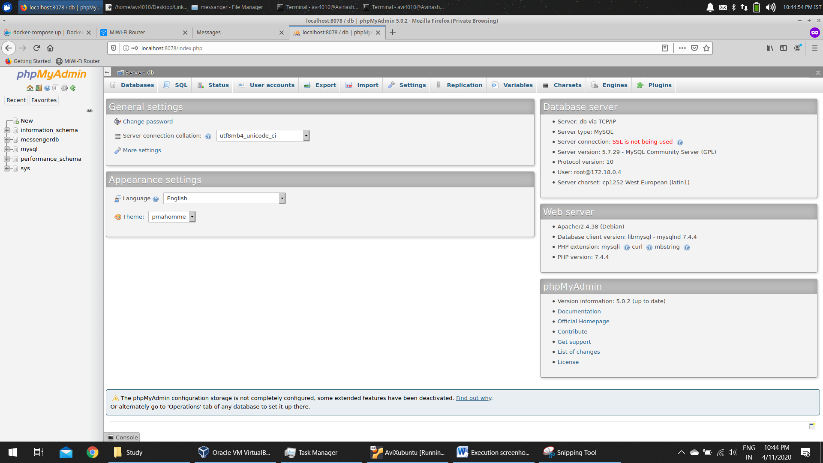

Click on the messages table hyperlink

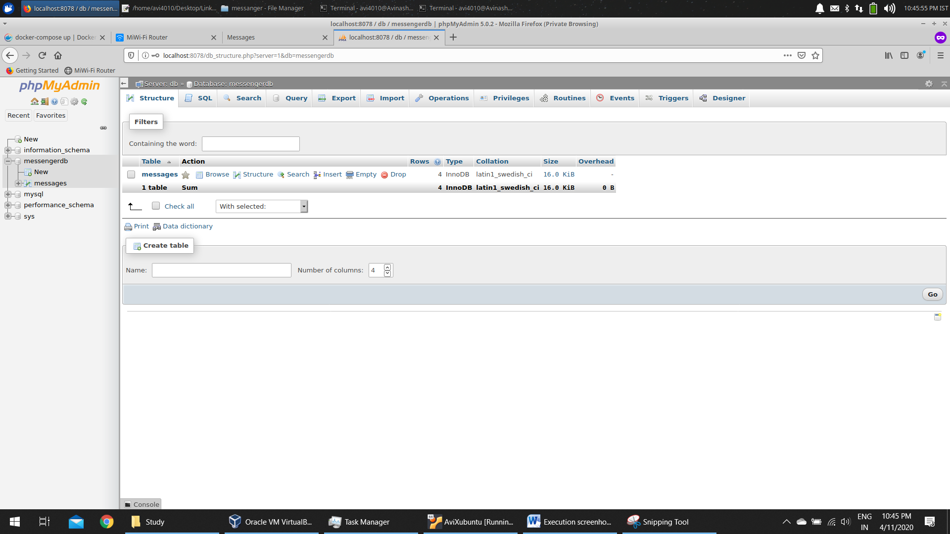

All the data entered in UI is displayed in MySQL DB

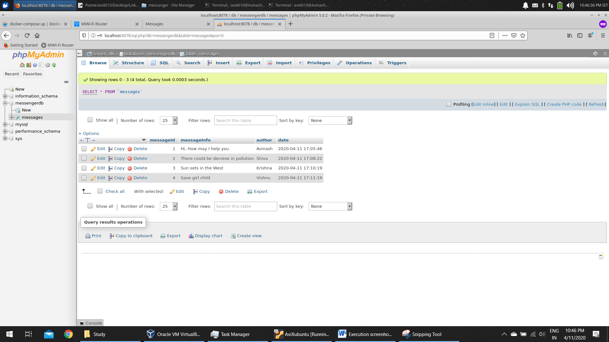

Click on SQL hyperlink on top of the page

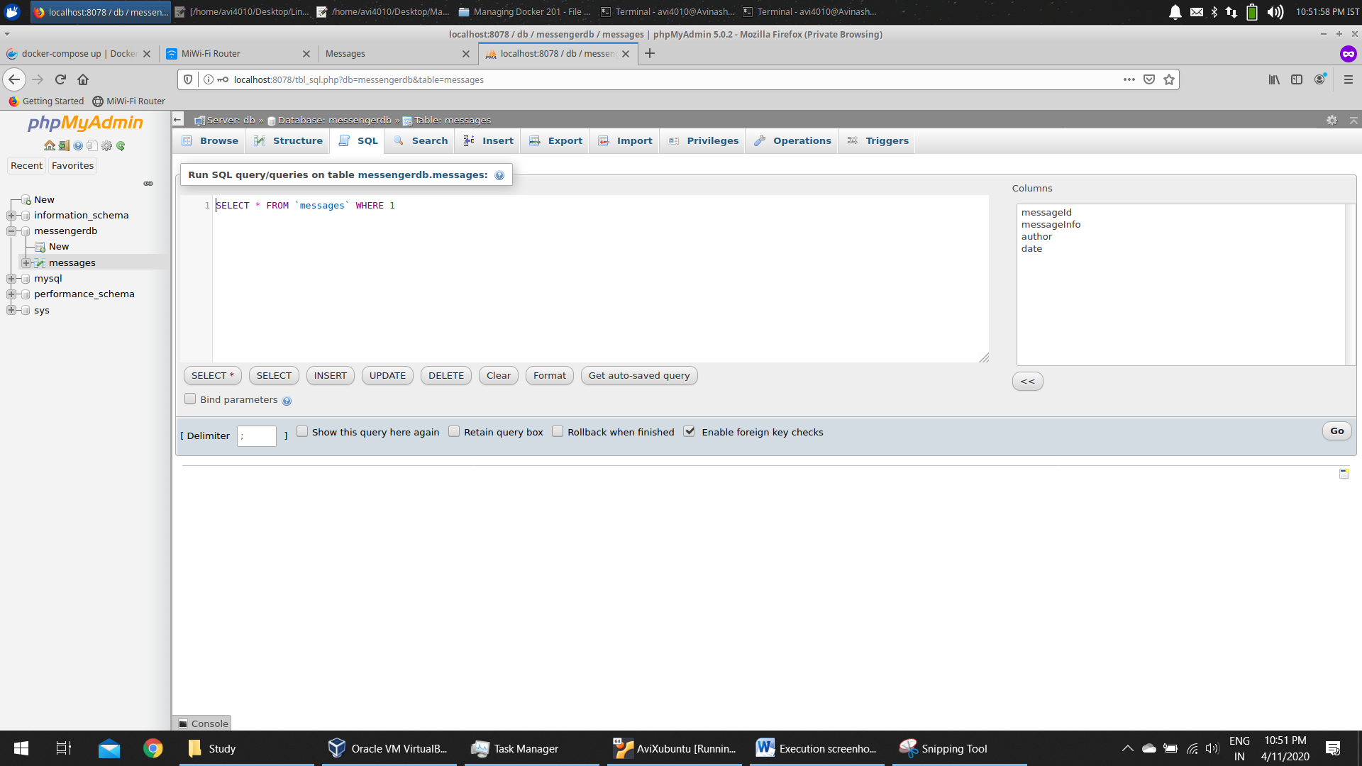

Execute the below query

INSERT INTO messages (messageInfo, author, date) VALUES ("I am happy", "Jesus", "2020-03-30 23:08:32.12");

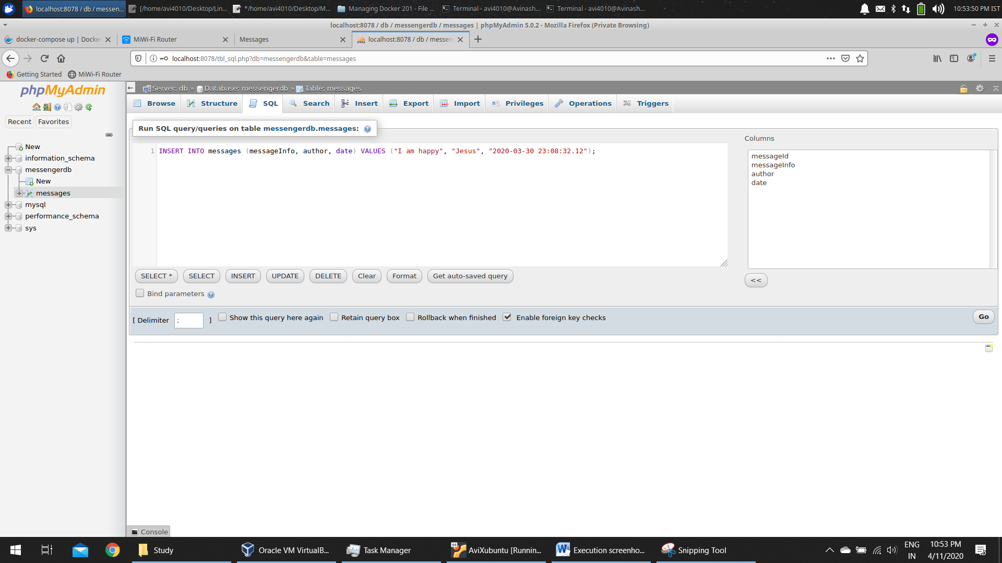

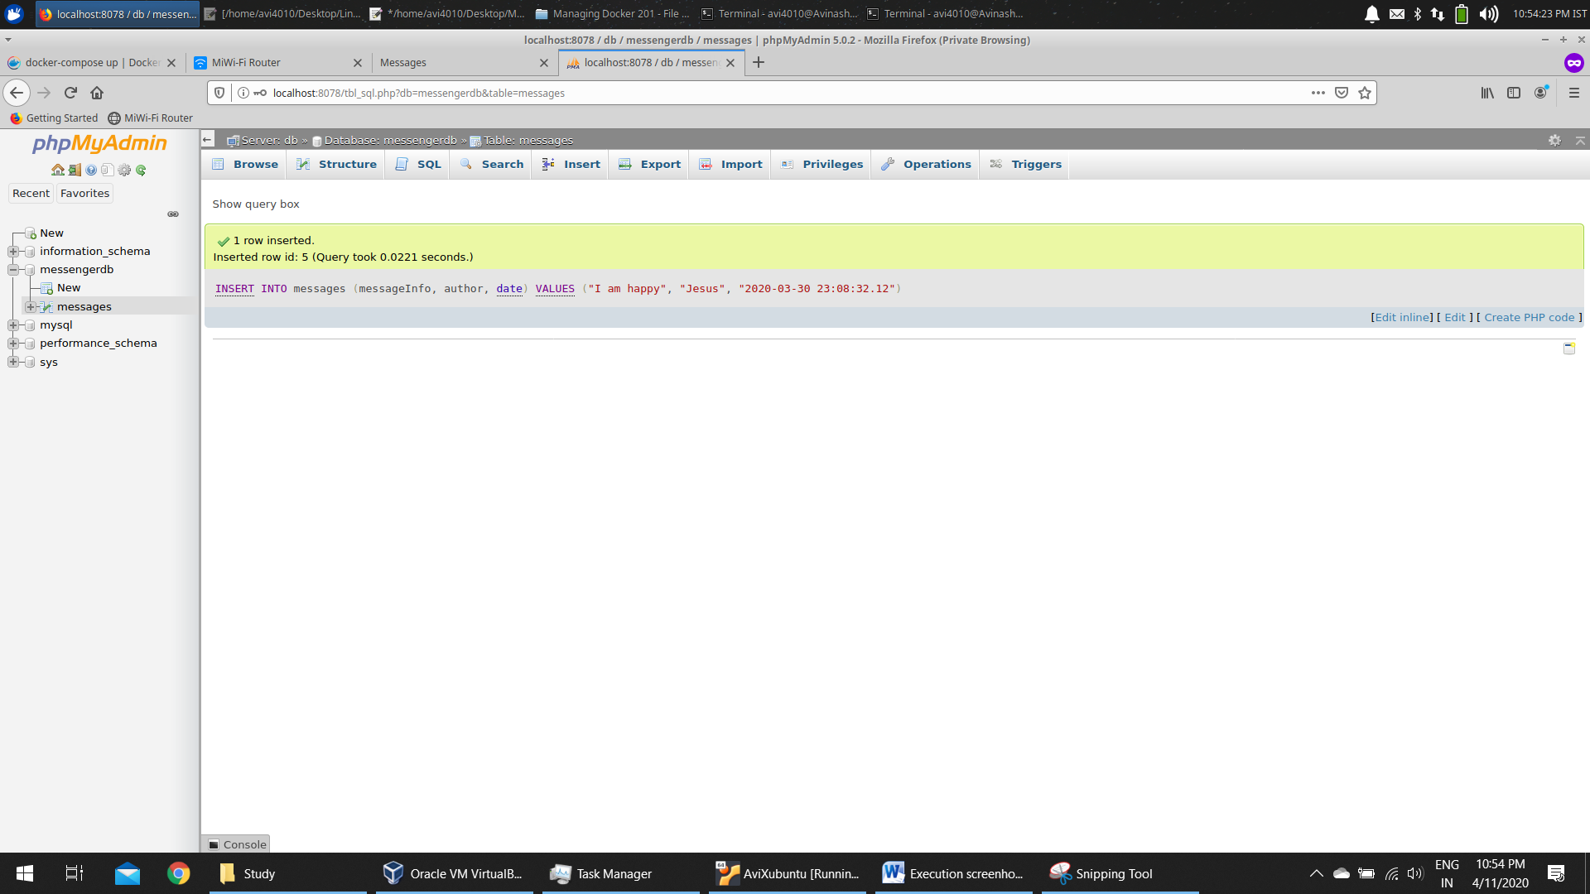

Refresh the Page in UI. Data entered in DB is displayed

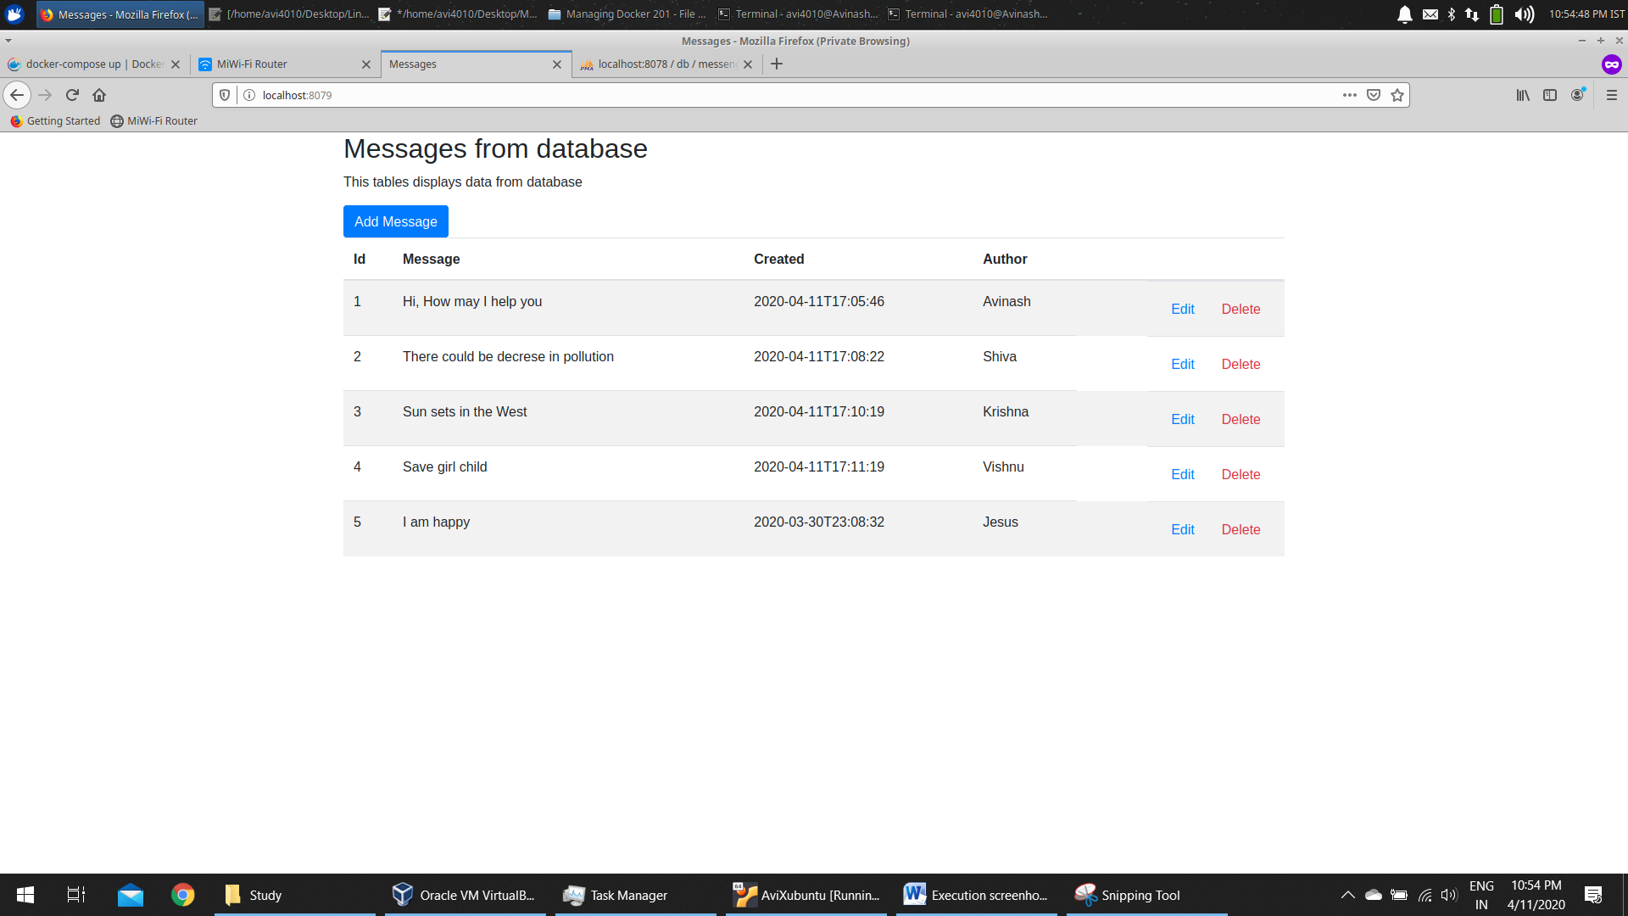

Click on edit for 4th row in UI

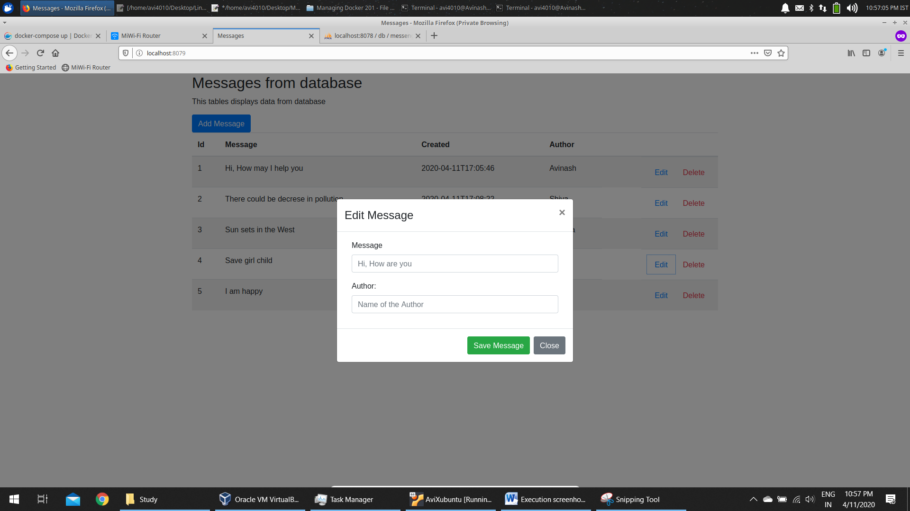

Enter New Values

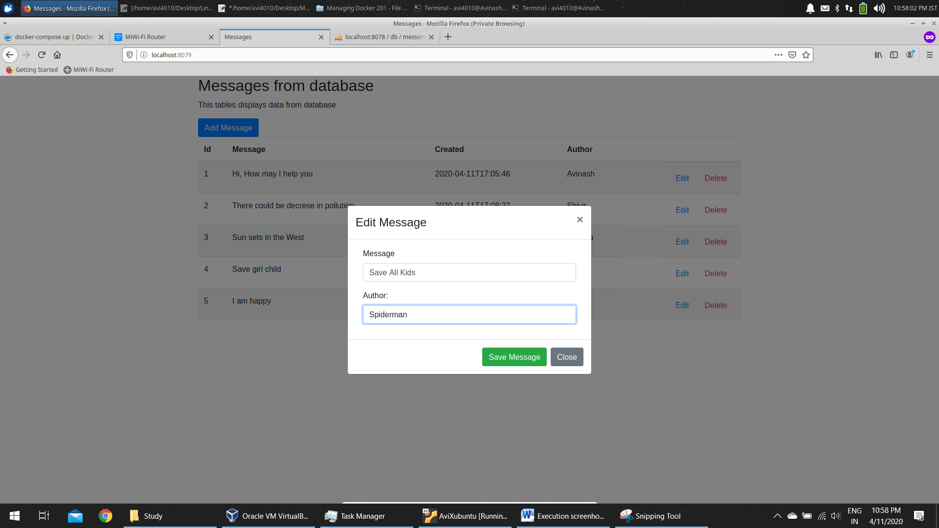

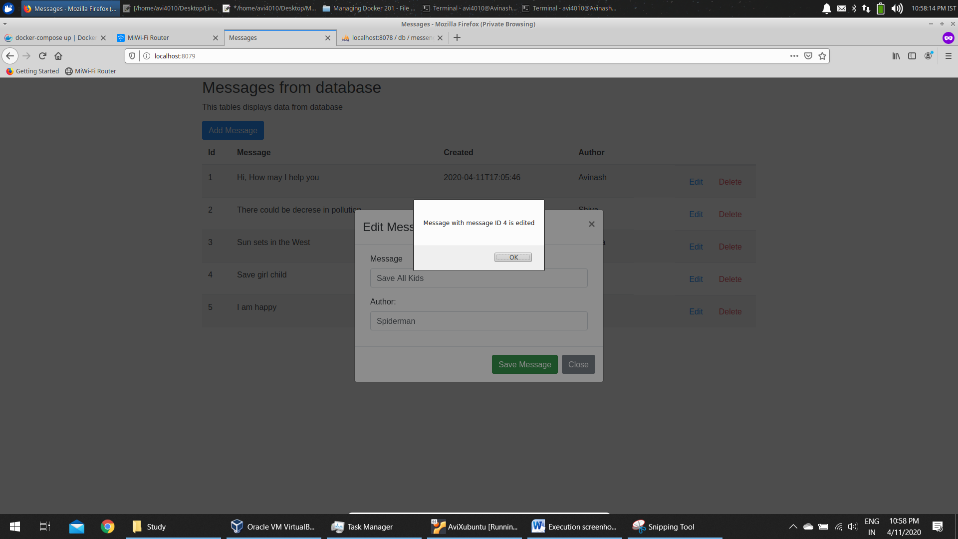

Value is updated

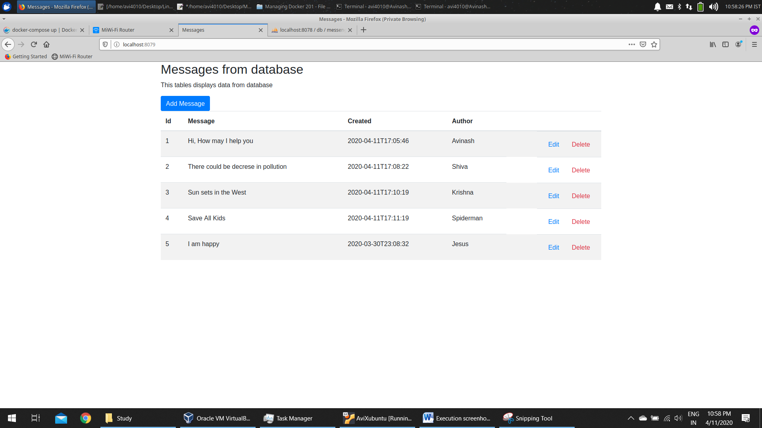

Delete 4th row in UI

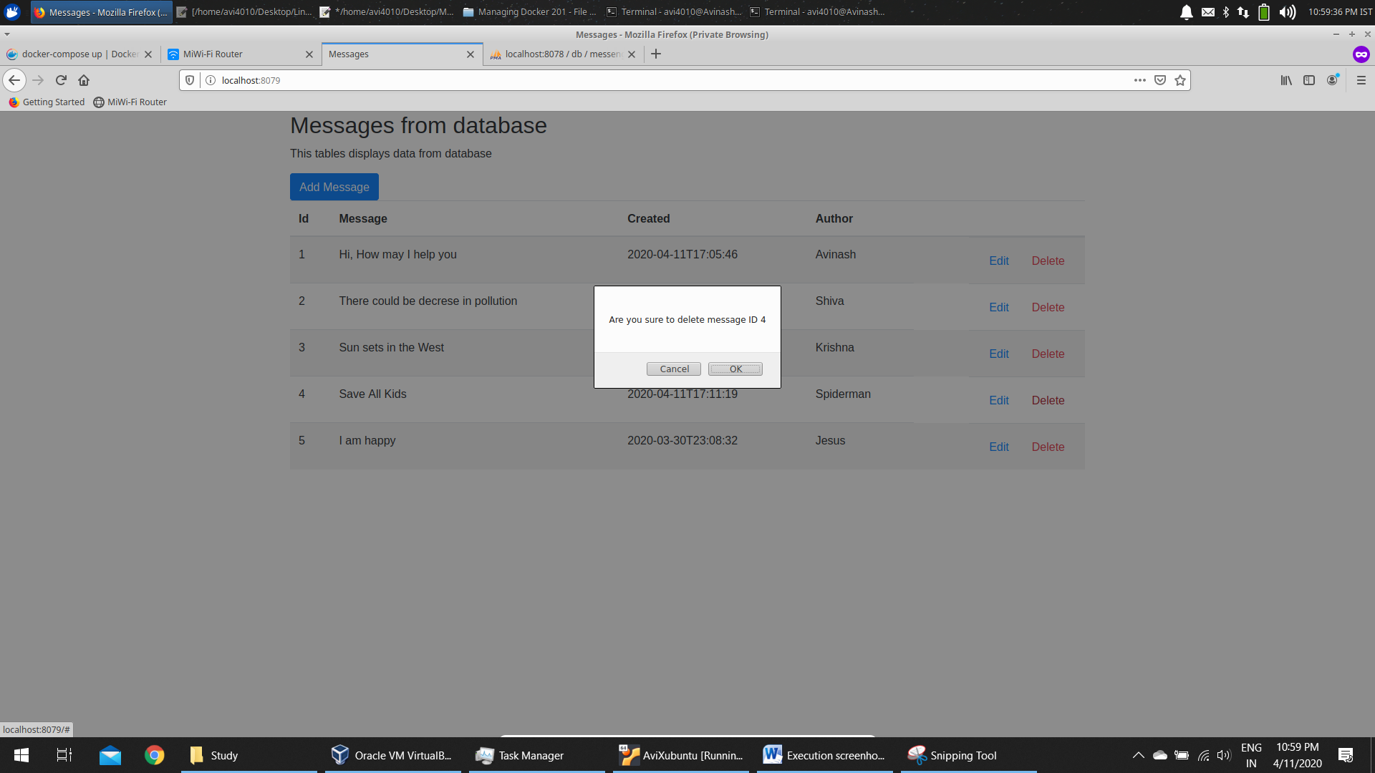

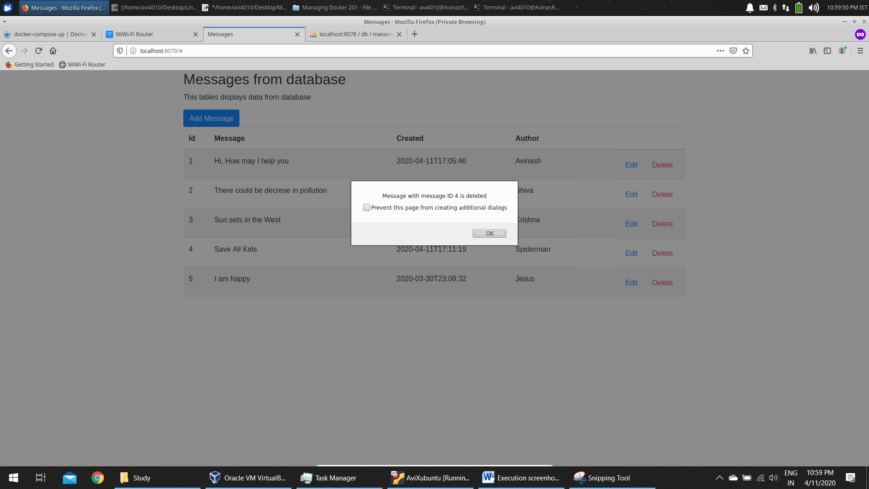

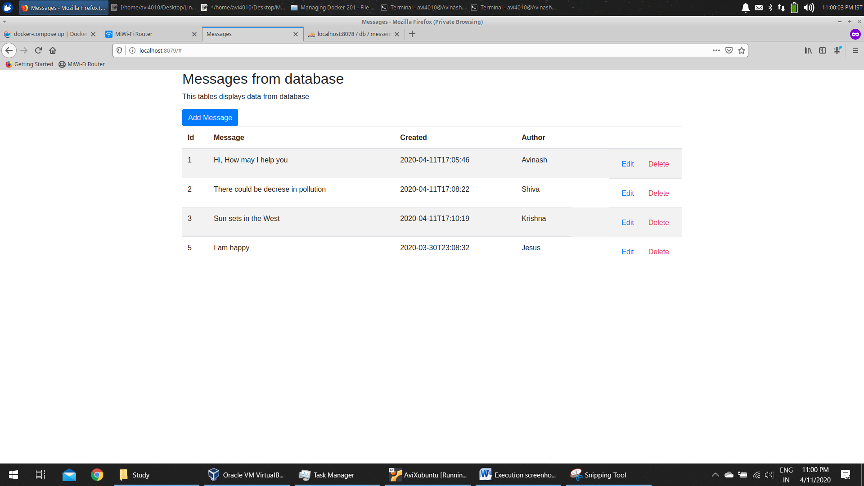

Check values in DB

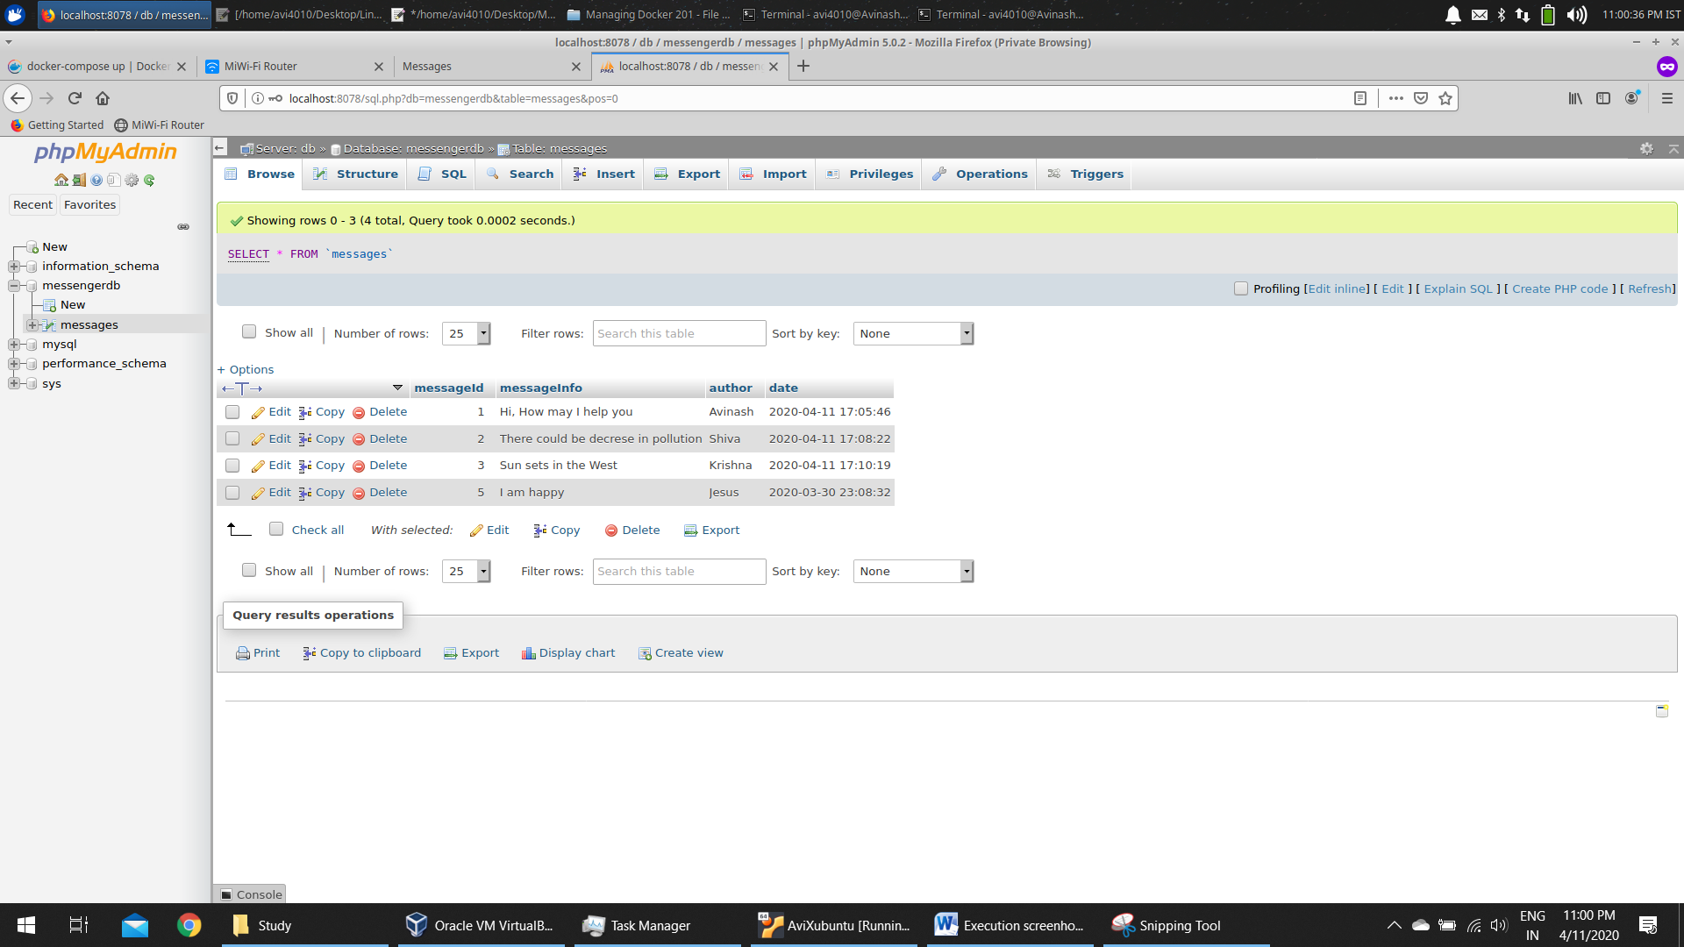

Bring down the application

Using **docker-compose down** command

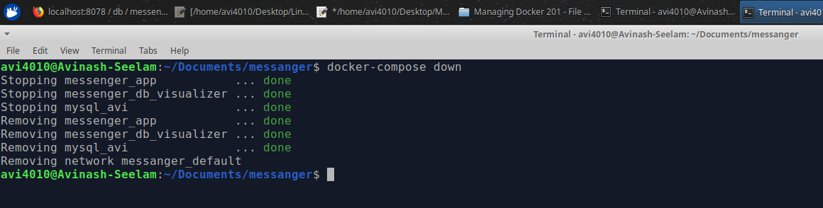

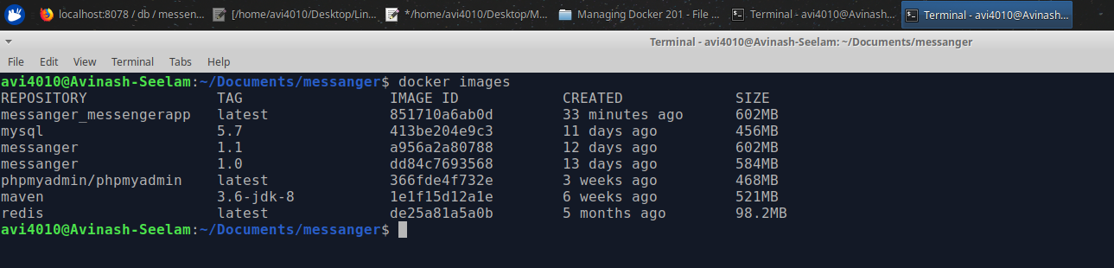

Check the application is no longer accessible

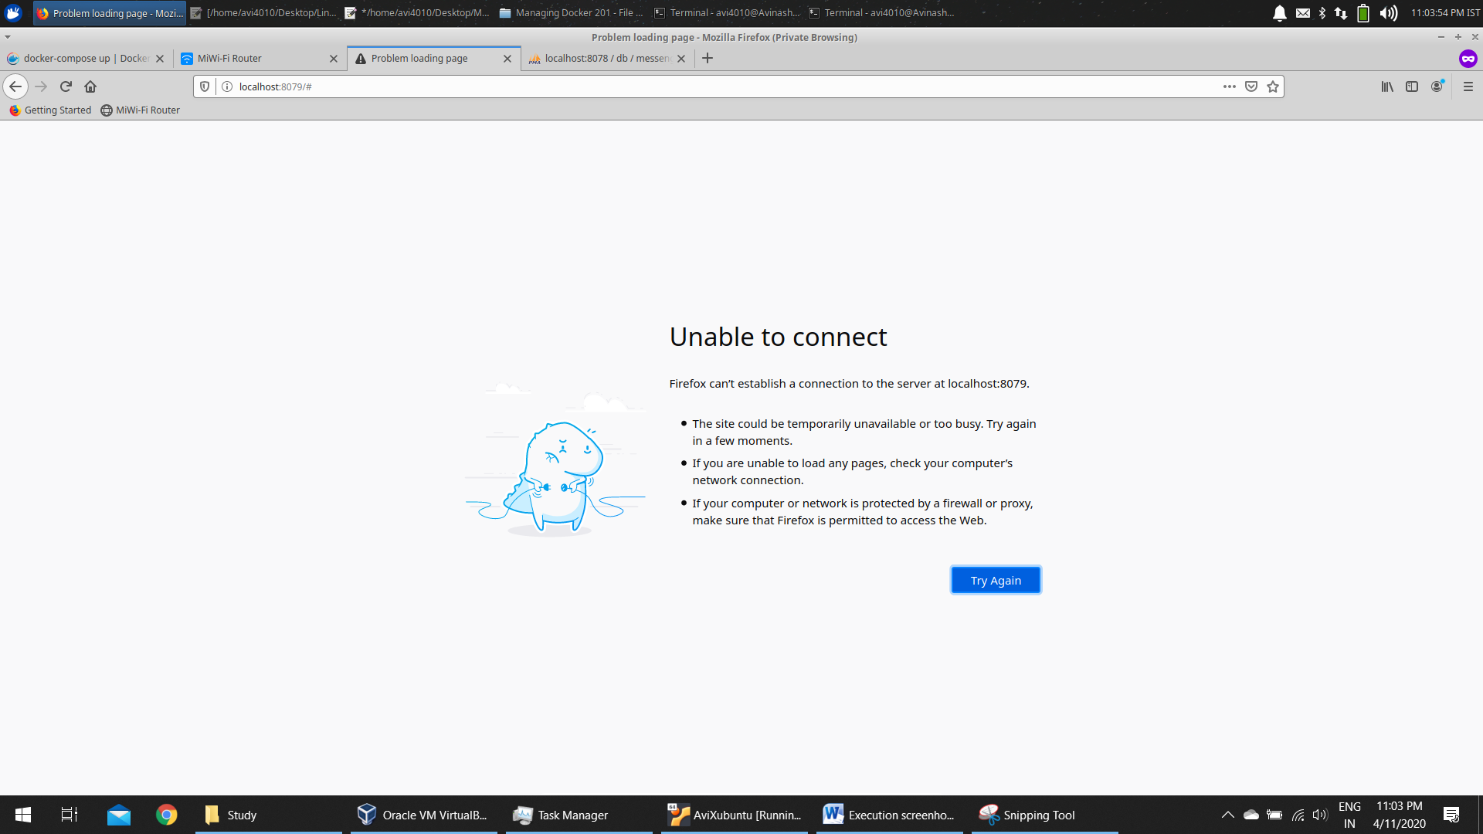

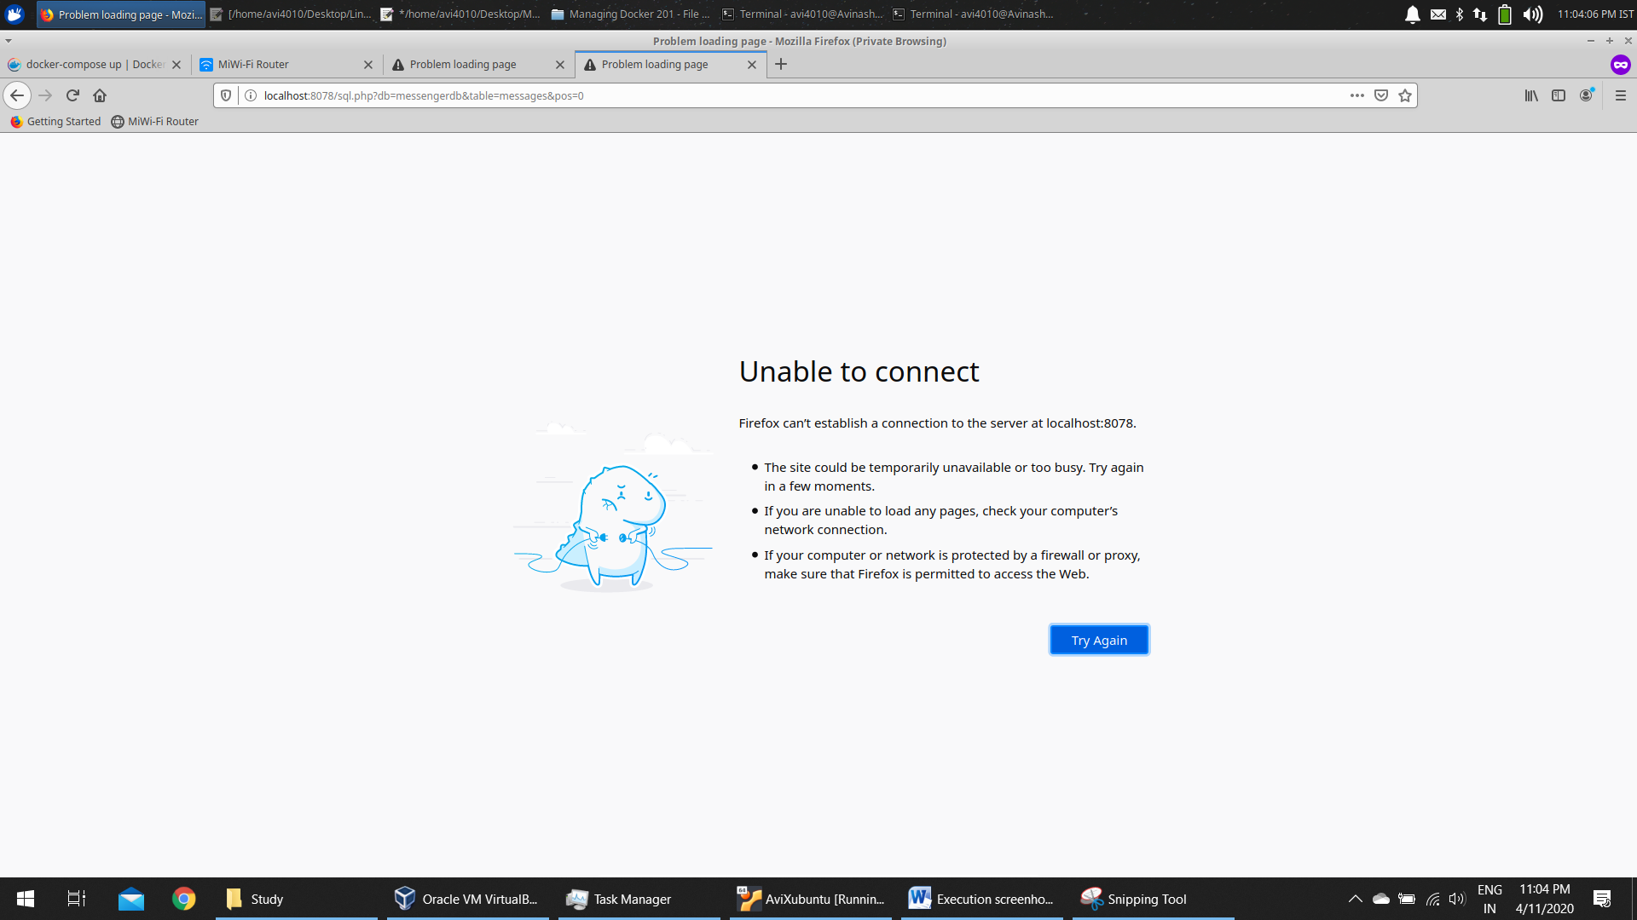

Again sping the application up

**docker-compose up -d**

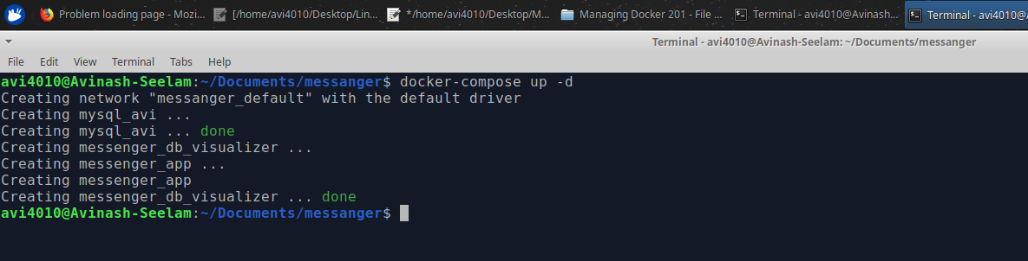

Now check the application status

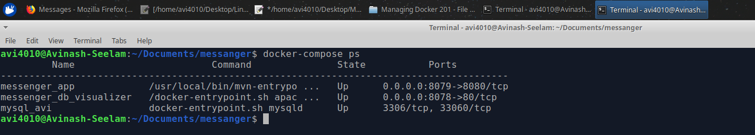

All the data which is stored earlier is still present even after spinning a new container

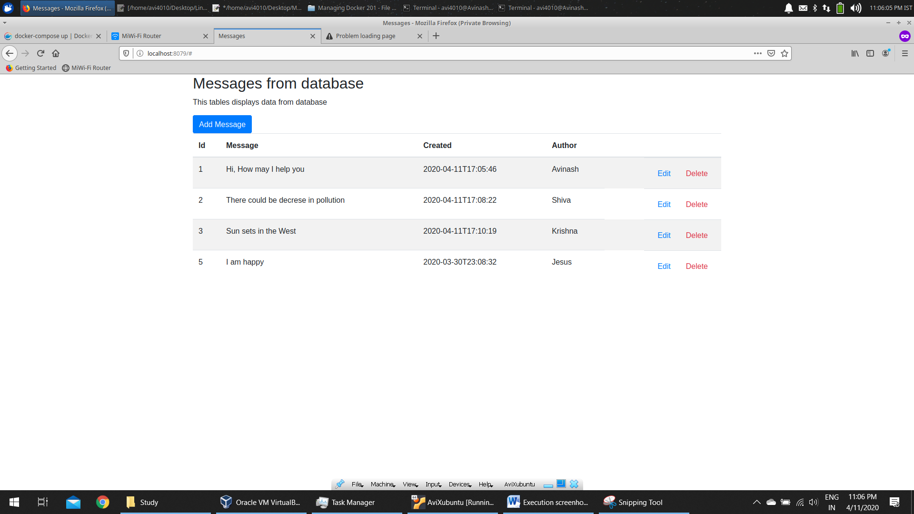

Able to access the DB as well

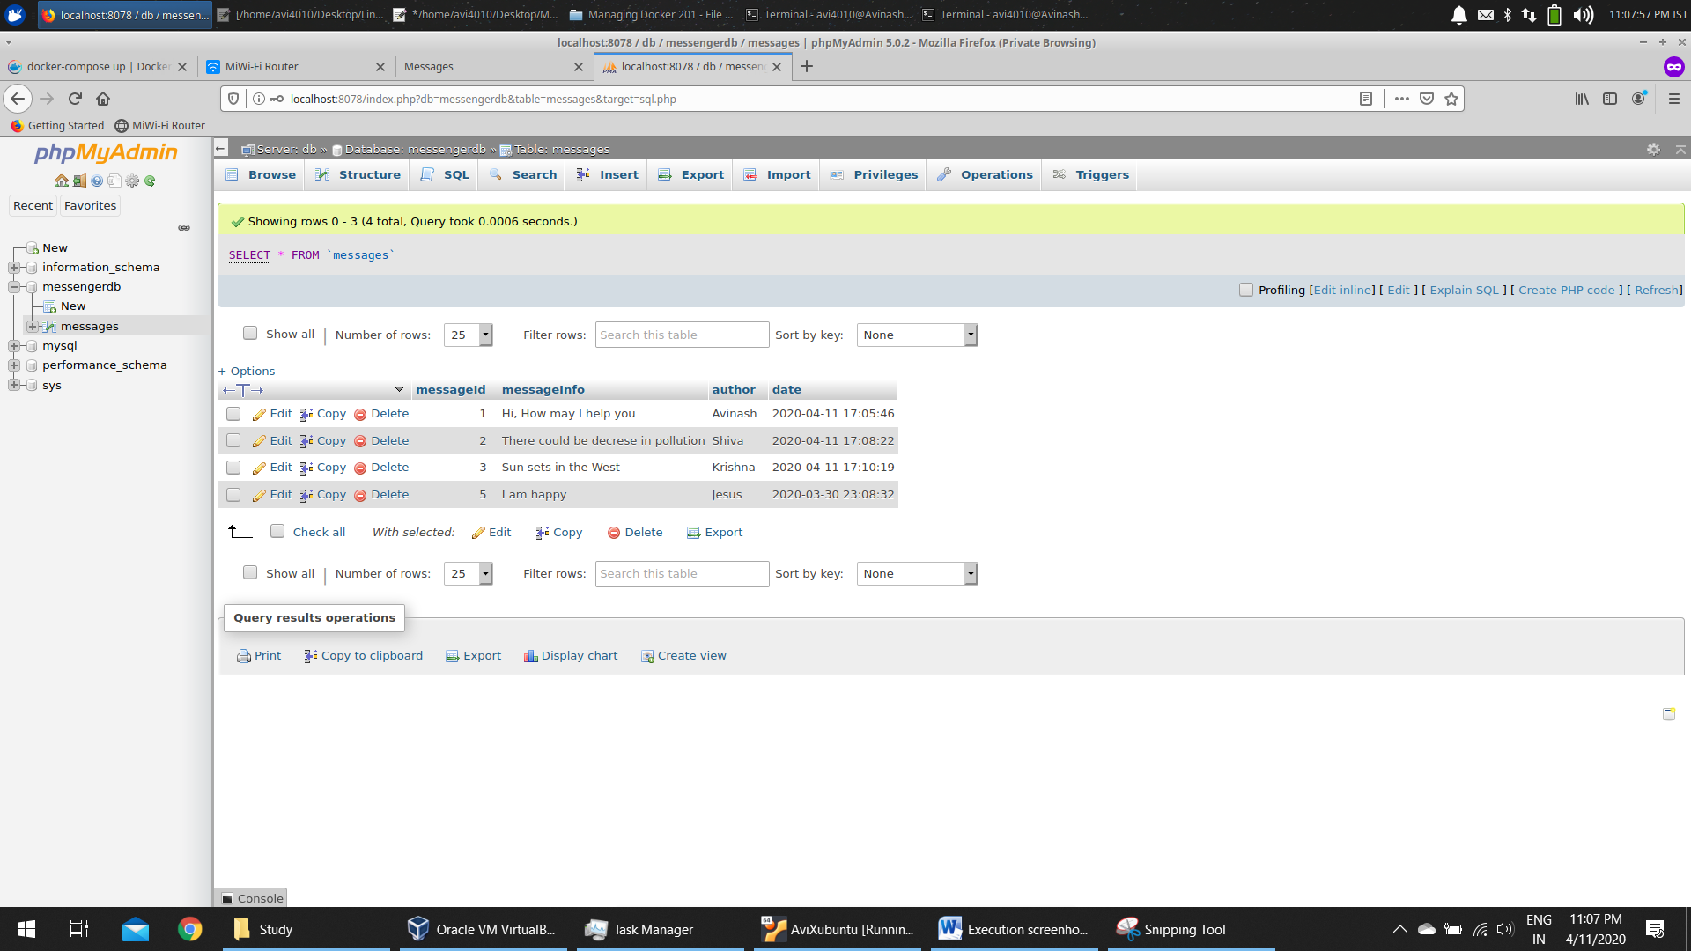

Alternate way to run the application

Navigate to the below location and open terminal in this location

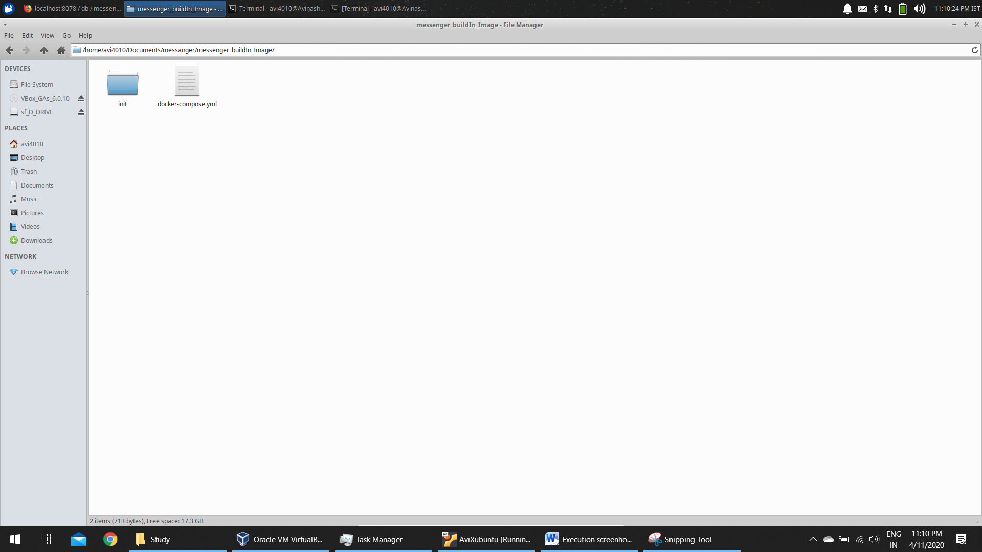

Type the below command

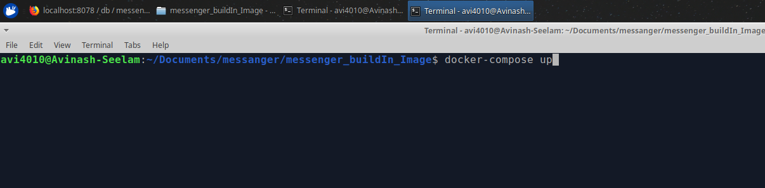

Docker Images in pulled from docker hub registory

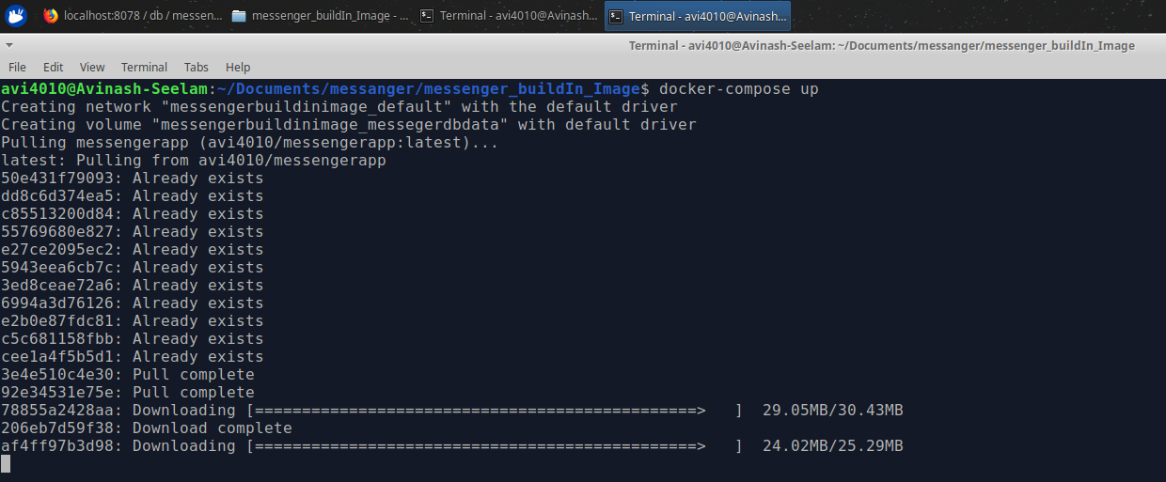

Application is up now. Open a new terminal and verify

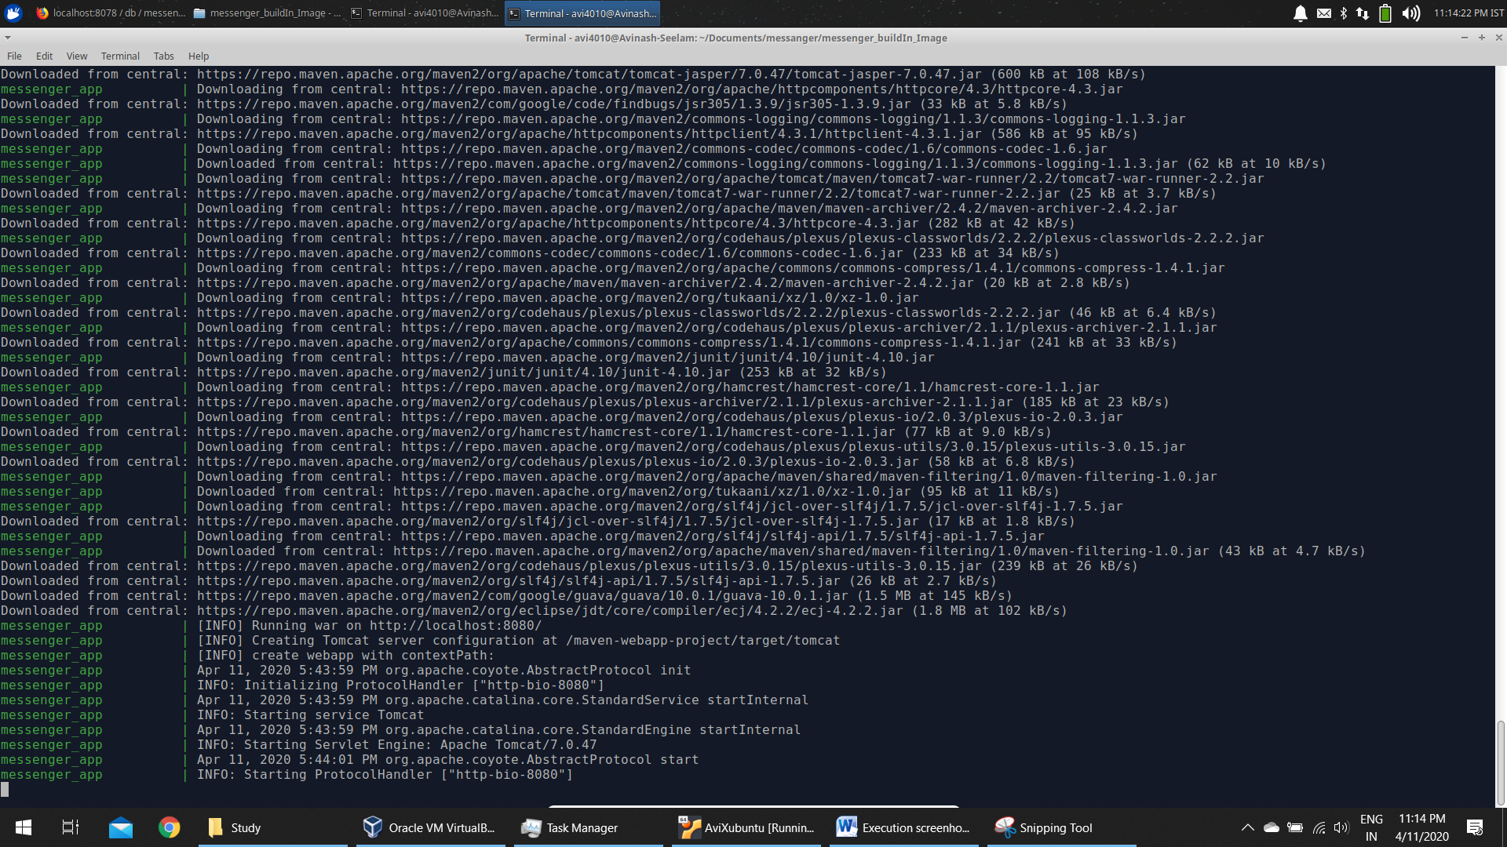

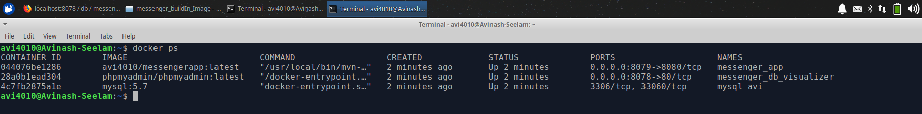

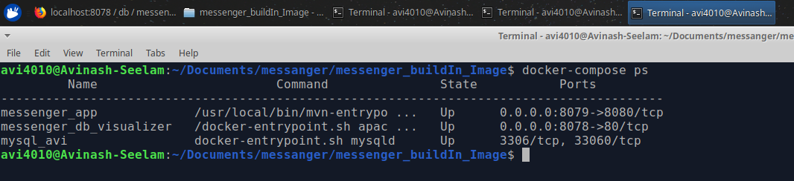

Now access the application

